Autounlock Control Function – CGEA1.3

Functional Description

This STSS handles the setting of the Autounlock feature. The Autounlock setting is a CAN message that is output by the IC as a command to the BCM to change or request the current status of the Autounlock feature. The Instrument Cluster uses the Autounlock status for the Message Center function to enable or disable the Autounlock feature in the BCM module.

Starting in MY2019 with U625/U611 the Settings are migrating from the cluster to Center stack. This STSS supports displaying settings in the cluster or configuring the cluster settings off if they are displayed in the Center stack.

The Autounlock feature, when active, unlocks all of the vehicle doors when the Key = OFF/ACC and the driver's door is open within 10 minutes.

Interfaces

Interface Context Diagram (I/O Block Diagram)

Figure 1: Autounlock Function Context Diagram

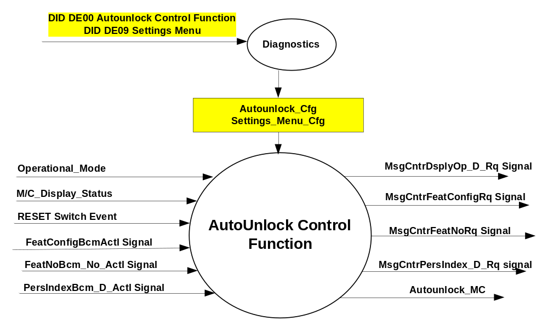

Inputs

- INTERNAL:
- Operational_Mode
- RESET Switch Event
- Autounlock_Cfg
- Settings_Menu_Cfg
- M/C_Display_Status
- MUX message on the CAN Bus from BCM

- FeatConfigBcmActl Signal
Signal Name | Size (bits) | Detail | Units | Res. | Offset | State Encoded | Min | Max
FeatConfigBcmActl | 16 | - | Undefined | 1 | 0 |  | 0  (0x0) | 65535  (0xFFFF)

- FeatNoBcm_No_Actl Signal
Signal Name | Size (bits) | Detail | Units | Res. | Offset | State Encoded | Min | Max
FeatNoBcm_No_Actl | 16 | - | Number | 1 | 0 |  | 0  (0x0) | 65535  (0xFFFF)

- PersIndexBcm_D_Actll Signal
Signal Name | Size (bits) | Detail | Units | Res. | Offset | State Encoded | Min | Max
PersIndexBcm_D_Actl | 3 |  | SED | 1 | 0 |  | 0  (0x0) | 1  (0x7)
 |  | PERS_1 |  |  |  | 0 (0x0)
 |  | PERS_2 |  |  |  | 1 (0x1)
 |  | PERS_3 |  |  |  | 2 (0x2)
 |  | PERS_4 |  |  |  | 3 (0x3)
 |  | Vehicle |  |  |  | 4 (0x4)
 |  | Unused |  |  |  | 5(0x5)
 |  | Unused |  |  |  | 6 (0x6)
 |  | Unused |  |  |  | 7 (0x7)

Outputs
- Autounlock_MC
- MUX message on the CAN Bus

- MsgCntrDsplyOp_D_Rq Signal
Signal Name | Size (bits) | Detail | Units | Res. | Offset | State Encoded | Min | Max
MsgCntrDsplyOp_D_Rq | 3 |  | SED | 1 | 0 |  | 0  (0x0) | 1  (0x7)
 |  | NULL |  |  |  | 0 (0x0)
 |  | QUERY |  |  |  | 1 (0x1)
 |  | SET |  |  |  | 2 (0x2)
 |  | UPLOAD |  |  |  | 3 (0x3)
 |  | RESTORE |  |  |  | 4 (0x4)
 |  | COPY |  |  |  | 5(0x5)
 |  | Not used |  |  |  | 6 (0x6)
 |  | Not Used |  |  |  | 7 (0x7)
.
- MsgCntrFeatConfigRq Signal
Signal Name | Size (bits) | Detail | Units | Res. | Offset | State Encoded | Min | Max
MsgCntrFeatConfigRq | 16 |  | Undefined | 1 | 0 |  | 0  (0x0) | 65535  (0xFFFF)

- MsgCntrFeatNoRq Signal
Signal Name | Size (bits) | Detail | Units | Res. | Offset | State Encoded | Min | Max
MsgCntrFeatNoRq | 16 |  | Number | 1 | 0 |  | 0  (0x0) | 65535  (0xFFFF)

- MsgCntrPersIndex_D_Rq Signal
Signal Name | Size (bits) | Detail | Units | Res. | Offset | State Encoded | Min | Max
MsgCntrPersIndex_D_Rq | 3 |  | SED | 1 | 0 |  | 0  (0x0) | 1  (0x7)
 |  | PERS_1 |  |  |  | 0 (0x0)
 |  | PERS_2 |  |  |  | 1 (0x1)
 |  | PERS_3 |  |  |  | 2 (0x2)
 |  | PERS_4 |  |  |  | 3 (0x3)
 |  | Vehicle |  |  |  | 4 (0x4)
 |  | Not Used |  |  |  | 5(0x5)
 |  | Not Used |  |  |  | 6 (0x6)
 |  | Not Used |  |  |  | 7 (0x7)

Function/Performance

Operational Modes

Mode | Differentiating Vehicle Conditions
Sleep Mode | Autounlock Control Function Text Message Disabled
Limiting Mode | Autounlock Control Function Text Message Disabled
Normal Mode | Autounlock Control Function Text Message Enabled / Disabled
Crank Mode | Autounlock Control Function Text Message Enabled / Disabled

Voltage Levels

Refer to the Cluster Features table located in the Operational Modes and Voltage Range Strategies Section in this SPSS.

Human-Machine Interface

Visual

Indicator Graphics / Display Format
For High End Display (SHMI), refer to “<Program> Cluster Menu Structure.xls” and Program VAPS Model.

Menu level 3 | Menu level 4 |  | Menu level 5
Locks | T: Locks | ▪ | ▪
Locks | Autounlock |  | T: Autounlock
Locks | Autounlock | ● | On (default setting)
Locks | Autounlock | ❍ | Off

For B Display, refer to Message Center Function description reference "B Display 2x14 Text Message List.xls"– Message ID SU210.

Indicator Color Coordinates

Reference section COLOR & ILLUMINATION REQUIREMENTS (GRAPHICS)

Indicator Characteristics

Refer to Message Center X Display_Y Button Interface Section, where X and Y are appropriate values in this document.

Audio

None

Switch Control Logic

Consumer access to the Autounlock Control Configuration shall be as specified in the message center basic functionality display as specified in Message Center X Display_Y Button Interface Section, where X and Y are appropriate values in this document.

System Accuracy

Within a 150msec of receiving a message that results in a change of state the cluster will update the display to the proper status.

Operation: Performance and Functional

Subsystem Algorithm Flowchart / State Diagram

Figure 2 Autounlock Diagnostic Configuration Flowcharts
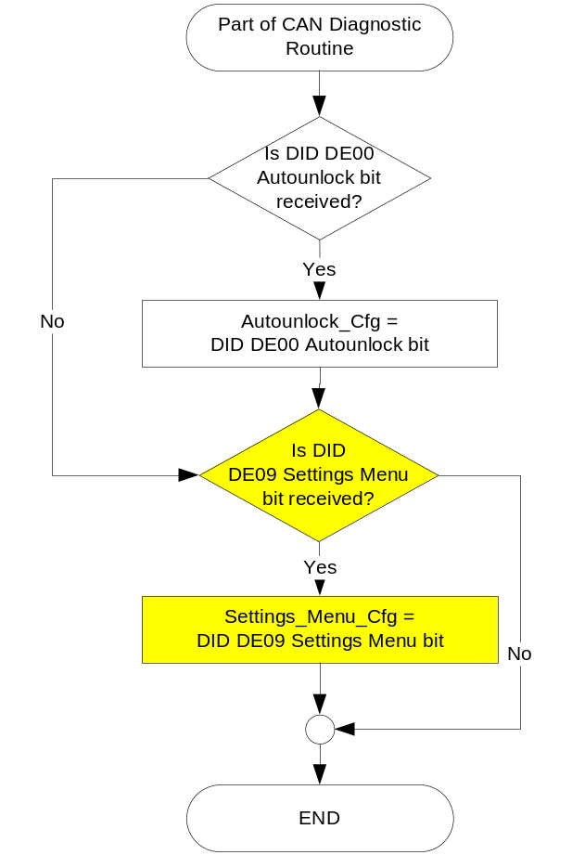

Figure 3: Autounlock output SET request Flowcharts

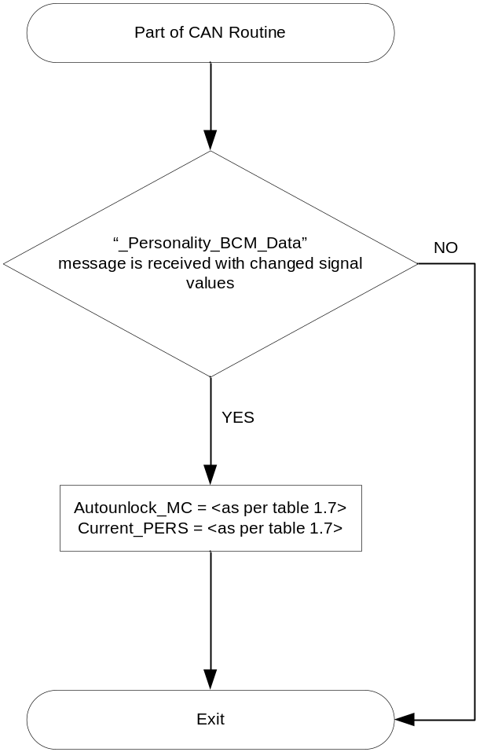

Figure 4: Autounlock output SET request Flowcharts

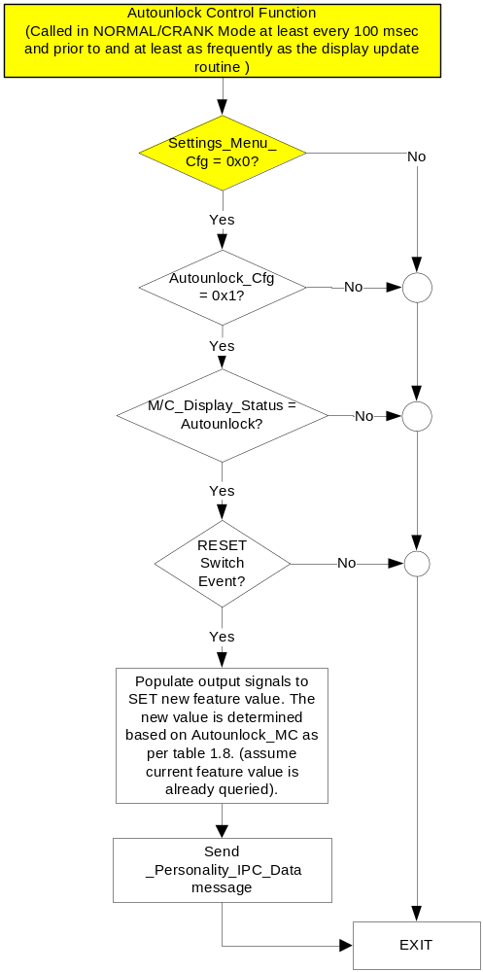

NOTE: In the Autounlock Function Flowchart, the definition of "RESET Switch Event" is defined in Message Center X Display_Y Button Interface Section, where X and Y are appropriate values in this document.

- Autounlock_MC State Assignment

FeatNoBcm_No_Actl | FeatConfigBcmActl | PersIndexBcm_D_Actl | Autounlock_MC | Current_PERS ⁽⁴⁾
0x404 ⁽¹⁾ | Disabled  (0x0000) | 0x0 – 0x4 | Disabled  (0x0) | 0x0 – 0x4
0x404 ⁽¹⁾ | Enabled  (0x0001) | 0x0 – 0x4 | Enabled  (0x1) | 0x0 – 0x4
0x404 ⁽¹⁾ | Other ⁽²⁾ |  | Not Supported (0x3) | Last known
Missing per Section 1.4.1 ⁽³⁾ |  |  | Error  (0x2) | Last Known

⁽¹⁾ Autounlock Feature Number. Reference is Feat Num table in “Vehicle Personalization FS”
⁽²⁾ Message Response is faulted
⁽³⁾ Equal to the received “PersIndex<--->” signal value . When faulted Keep last known value.

- Message Center Display and MC Autounlock Request Messages

based upon Autounlock_MC

Autounlock_  MC | MC Display  MSG. ID: SU210 | MsgCntrDsplyOp_D_Rq  Signal | MsgCntrFeatNoRq  Signal | MsgCntrFeatConfigRq  Signal | MsgCntrPersIndex_D_Rq  Signal
Disabled  (0x0) | AUTOUNLOCK  ON <OFF> | SET (0x2) | 0x404 | Enabled (0x1) | Current_PERS
Enabled  (0x1) | AUTOUNLOCK  <ON> OFF | SET (0x2) | 0x404 | Disabled (0x0) | Current_PERS
Error  (0x2) | AUTOUNLOCK  ON OFF | SET (0x2) | 0x404 | Enabled (0x1) | Current_PERS
Not Supported  (0x3) | AUTOUNLOCK  ON OFF | SET (0x2) | 0x404 | Enabled (0x1) | Current_PERS

- This feature will be set to ENABLED at the instrument cluster manufacturing plant. It will be set via diagnostic at Vehicle Operations using DID DE00. Autounlock_Cfg is set equal to the last value received in the diagnostic routine.

- The customer will have the ability to change the Autounlock to Enabled or Disabled when the Instrument Cluster Message Center (IC) is enabled (Operational Mode is Normal).

Operation Description (supports algorithm flowchart /state diagram)

Function Safety Classification (EMC)

Class B

Memory Storage

Parameter Name | Description | Value at  Battery Connect | Value at  Module Wake-up
Autounlock_MC | Output displayed in the M/C. | ERROR (0x2) | Do Not Init
Current_PERS | Current Personality Profile | Vehicle (0x4) | Do Not Init
MsgCntrDsplyOp_D_Rq Signal | Output Signal to indicate Request Type. | NULL (0x0) | Do Not Init
MsgCntrFeatNoRq Signal | Output Signal to indicate Feature Number. | (0x0000) | Do Not Init
MsgCntrFeatConfigRq Signal | Output Signal to Specify the desired feature Value. | (0x0000) | Do Not Init
MsgCntrPersIndex_D_Rq Signal | Output Signal to indicate which personality profile is being accessed. | PERS_1 (0x0) | Do Not Init
FeatNoBcm_No_Actl Signal | Input signal sent from BCM to indicate Feature Number. | (0x0000) | Do Not Init
FeatConfigBcmActl Signal | Input signal sent from BCM to indicate current value of the feature setting for the feature that is being set or queried. | (0x0000) | Do Not Init
PersIndexBcm_D_Actl Signal | Input signal sent from BCM to indicate which personality profile is being reported. | PERS_1 (0x0) | Do Not Init
Autounlock_Cfg | Configures cluster to allow Autounlock (Set to enabled at cluster supplier manufacturer plant.) | Use Stored Value | Use Stored Value
Settings_Menu_Cfg | Configures cluster to display items in the Settings menu (Set to “cluster” at cluster supplier manufacturer plant) | Use Stored Value | Use Stored Value
M/C_Display_Status | State Indicator to identify which text is currently being displayed on Message Center display. See * | See * below | See * below
RESET Switch Event | Event that is indicated as per the switch interface for the Message Center. See * | See * below | See * below
Operational_Mode | 4 state indicator for cluster operational mode | Limited | Limited, Normal or Crank
* Refer to Message Center X Display_Y Button Interface Section, where X and Y are appropriate values in this document.

Reconfigurable Telltale
Not Applicable

Prove Out
Not applicable

Message Center Msg

Refer to Message Center Function description reference "B Display 2x14 Text Message List.xls",
"E Display 2x14 Text Message List.xls" or "A Display Text Message List" file – Message ID SU210

Error Handling

Missing Message Strategy

The signals will be declared missing as per the Diagnostics section of this SPSS.

DTCs states and history will be determined as per the Diagnostics section of this SPSS.

Diagnostics

Self Test
None

Engineering Test Mode
Reference section “Dealer / Engineering Test Mode (ETM)”

Part II Performance

Supported Diagnostic Trouble Codes (DTCs)
DTC | Description
C14000 | Lost of Communication with BCM

DID DExx:
Block  Num | Block Description | Byte(s) | Bits | State: Description | "0" | "1" | Default | Comments/  Information
PACKETED BLOCKS
$00 | Option Content (B&A) | * | * | Autounlock Control Function | Disabled | Enabled | Enabled | This parameter allows the Autounlock settings menu to be displayed in the cluster. It can be over-ridden by the Settings Menu config.
$09 | Option Content (B&A) | * | * | Settings Menu | Cluster | Center Stack | Cluster | This parameter allows the Settings menu to be displayed in the cluster when 0x0. When 0x1, the expectation is that settings are displayed in the Centerstack. For this feature (when 0x1), the cluster will remove almost all items from settings menu. (Cluster display choices remain). Note this is a global config, each feature still has its own config for presence on vehicle.
*Byte and bit location to be identified in Part II Specification for this cluster

Reference Specification

LA-0025 PROGRAMMABLE AUTOLOCK AND AUTOUNLOCK

Revision History
SPSS Module Revision History

Revision Level | Name | Change Description | Date
1.0 | V. Patel | Updated for CGEA 1.3 based on CGEA STSS v2.1  Section 1.2.2 – Removed table referencing the HS-CAN message that contains the input signal.  Section 1.2.3 – Removed table referencing the HS-CAN message that contains the output signal.  Section 1.2 – Deleted “Position” column from the input and output signal tables.  Section 1.4 – Rewritten. Deleted references of specific missing message flags and timer.  Section 1.5.3 – Deleted DTC logging criteria from the table. | 4/19/2010
2.0 | S. Watkins | The RFA module was merged into the SPDJB for CGEA 1.3. Thus, all references to the RFAM are being removed from this STSS. This includes removal of all refernces to:  FeatNoRfaActl Signal (PEPS)  FeatConfigRfaActl Signal (PEPS)  PersIndexRfa_D_Actl Signal (PEPS)  PEPS_Cfg  - Section 1.1 – Description updated to remove references to RFA  - Section 1.2.1 – Deleted Figure 1 (prior Figure 2 is now Figure 1)  - Section 1.2.2 – Deleted the 3 RFA signals  - Section 1.3.5.1 – Deleted PEPS_Cfg from Figure 2. Deleted RFA signal from Figure 3 decision diamond. Deleted 3 RFA signals from Table 1.7.  - Section 1.3.5.4 – Deleted 3 RFA signals and PEPS_Cfg from table.  - Section 1.5.3 – Deleted PEPS_Cfg from DID DE00. | 1/19/2011
3.0 | S. Watkins | Starting in MY2019 with U625/U611 the Settings are migrating from the cluster to Centerstack. This STSS update is to support this effort. A configuration is added to ensure backward compatiblity.  Changes shown in yellow:  - Section 1.1 – Updated description to mention Center Stack  - Section 1.2.1, Figure 1 – Added DE09 Settings Menu  - Section 1.2.2 – Added Settings_Menu_Cfg  - Section 1.3.1 – Added “Enabled” to Crank mode (defect fix unrelated to other changes)  - Section 1.3.5.1, Figure 2 – Added DE09 Settings Menu  - Section 1.3.5.1, Figure 4 – Added decision box for Settings_Menu_Cfg and also added “Crank” to first box (defect fix unrelated to other changes).  - Section 1.3.5.4 – Added Settings_Menu_Cfg  - Section 1.5.3 – Added Settings Menu to DE09 | 1/6/2017

